How the Pacific could be California's drought fix
Thursday, 13 Feb 2014 | 4:03 PM ETCNBC.com
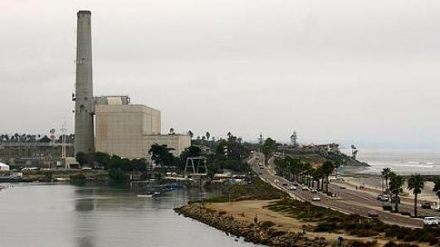
A desalination plant in Carlsbad, Calif.
Nearly every time California goes through a severe drought—and it's currently in a state of emergency from lack of rainfall—talk turns to using desalination to replenish water supplies. Lately, the talk is getting more ambitious.
The process of taking salt out of the Pacific Ocean already exists in the Golden State. But bigger and more expensive desalination plants are on the drawing boards, causing some experts to express the need for caution—even during one of the harshest dry spells.
'In light of the extreme drought in California, people are wondering how quickly desalination plants can come on line," said Christiana Peppard, a professor of theology at Fordham University and an expert on fresh water ethics. "But desalination is not a panacea. It's only as good as the contexts in which it is deployed and the goals that are set for it."
If desalination becomes more widespread in California, it must be done with an eye on the health of the ocean, said David Helvarg, executive director of Blue Frontier, an ocean preservation group.
"There are constant environmental challenges involved with desalination," he said. "It's energy-intensive and can do harm to the fish and marine life with the way it works. It has to be done right."
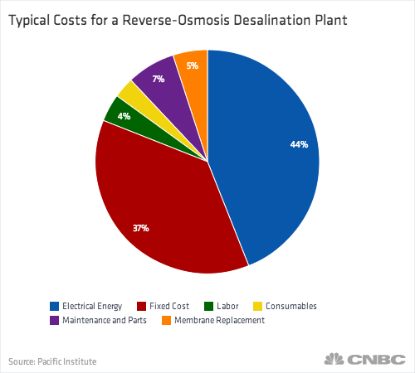
Proposed and new plants are much bigger
California has a half dozen desalination plants (the U.S. total is more than 300, experts say) mostly around the central coast in towns like Sand City, Marina and Cambria.
The Sand City plant, which became operational in 2010, produces about 98 million gallons of fresh water a year. Marina and Cambria are of comparable size.
In contrast, two major plants, one in Carlsbad and another in Huntington Beach, are expected to produce 50 million gallons of water a day. The Carlsbad facility, near San Diego, is under construction and scheduled to open in 2016 and become the largest desalination plant in the Western Hemisphere.
The Huntington Beach plant is still going through the state permit process for approval. Both are being designed and built by the water project development firm Poisedon Water.
"We have the largest reservoir of water (the Pacific Ocean) at our doorstep," said Peter Maclaggan, vice president of Poseidon. "It's the only source we can rely on that's not dependent on snowfall."
The cost to build the plants is high, said Maclaggan, The Carlsbad plant alone is a $922 million investment, with all the funding coming from the private sector. According to Maclaggan, Poseidon will get its money back only when it sells the water, and at a much higher price than non-desalinated water goes for.
Because the process of desalination is much more expensive than other ways of getting water, (energy used in desalination makes up a large percentage of the cost) water out of the tap will be more expensive to drink.
Instead of selling water at the average of around $1,150.00 an acre-foot to the local utility, the Carlsbad plant water will go for $2,000 an acre-foot, Maclaggan said. (One acre-foot is equal to 325,850 gallons) That has critics worried.
"The only way to make desal work is if there's some guarantees that the price of water can be lowered," said Leila Monroe, an attorney in the oceans program with the environmental group, the Natural Resource Defense Council.
Environmental costs
Besides the potentially higher cost of production, some experts worry that desalination comes with a high price tag for the environment.
It takes 2 gallons of seawater to make 1 gallon of fresh water, according to a report from the Pacific Institute, Those 2 gallons of seawater come through intake pipes that trap millions of marine organisms, said Blue Frontier's Helvarg,
And there's the outflow after the seawater is cleaned of salt, he said. The outflow, or salt brine, is pushed back into the ocean and sometimes contaminated with cleaning agents from the pipes, that again can kill marine life.
"We have to figure out a way of not putting the brine back in the ocean," Helvarg argued.
Another problem for desalination, said Helvarg, is creating a larger carbon footprint because of the increased amount of energy needed. However, Poseidon Water's Maclaggan said his firm is doing everything it needs to in order to protect the ocean as well as the sky.
"California has some of the strictest environmental regulations, and we're following them," he said. "We're working to resolve any issues involving the loss of marine life. When Carlsbad goes online it will be the most advanced technologically and sensitive to the environment."
Desalination in the U.S. goes back to 1958, when Congress authorized the government to construct and operate five desalination plants—one of those was a San Diego plant that has since closed.
—By CNBC's Mark Koba.

